SUMMER HOLIDAY HOME WORK -2021
CLASS-III EVS
Q1. Make a list of animals those who live on –
- Trees
- On land
- In and near water
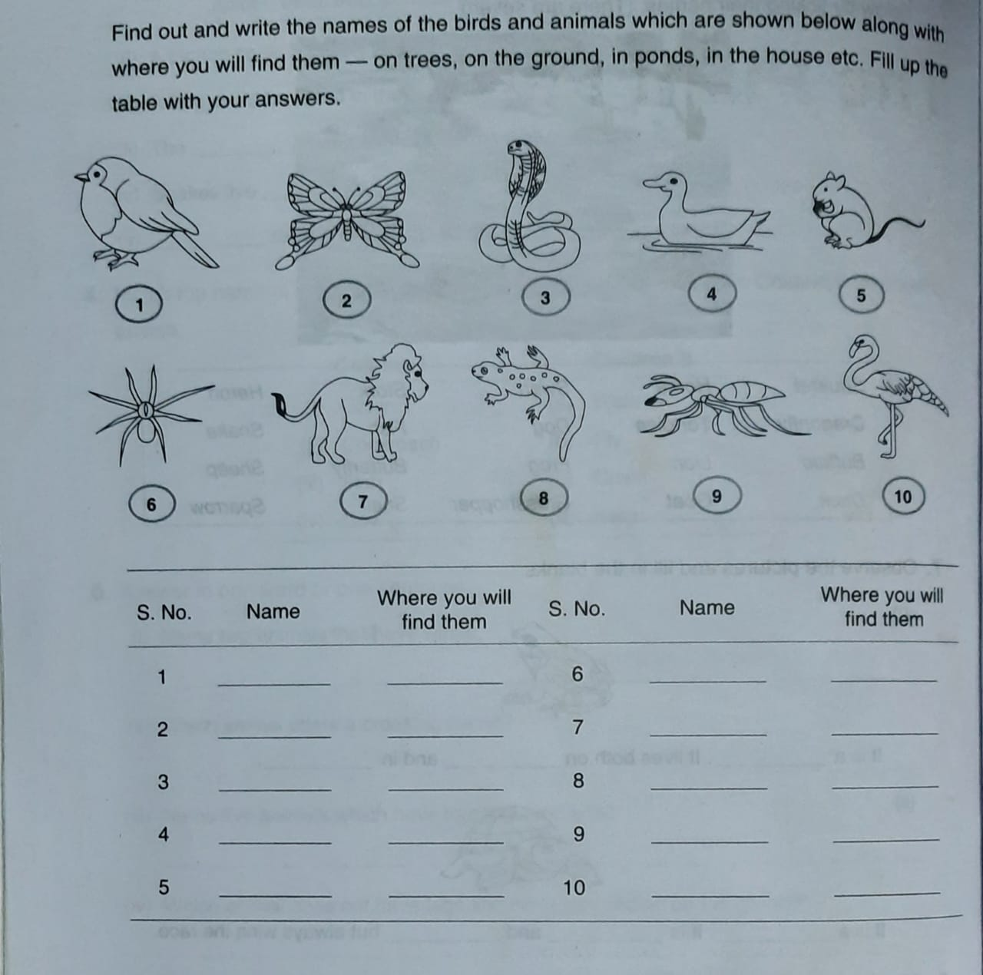
Q2.

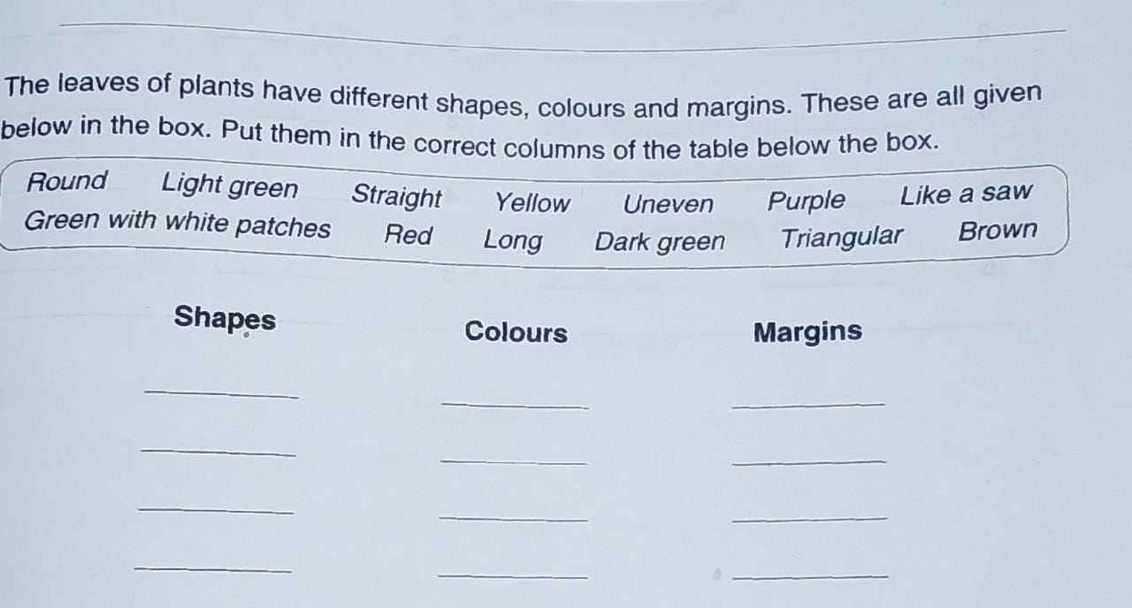
Q3.

Q4. Draw a picture of plant and label it.
Q5. As plants are important for us, plant a sapling and water it regularly. While planting make a short video.
Q5. Draw the picture of different containers which are used to store water.
Q6.Why do we need water?
Q7. Write some natural sources of water.
Q8. How you save water at your home? Write any two ways.
Q9. Make one greeting card .you can use water colour and finger prints / leaves to make different figure.

